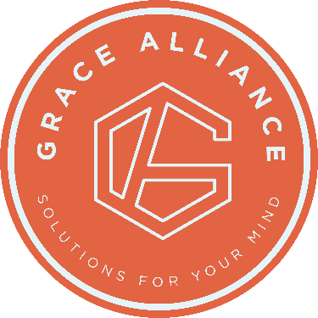

An innovative experience integrating science and your faith in Christ to renew your mental and emotional health.

Restore Life, purpose, and faith for you, your family, and marriage.

Living and Family Grace Groups are designed to provide healthy solutions for your heart and mind. In each chapter, you will find opportunities to transform your daily life. Both Scripture and Science will give you a new perspective and practical tools. These will help you address the challenges that come with living with any mental health difficulty or disorder.

Living Grace is uniquely designed to reduce symptoms caused by mental and emotional challenges, increase well-being, and renew faith

+ Manage stressors, tension, anxiety and depression,
+ Increase calm through rest, relaxation, and joy,
+ Decrease negative thoughts and reframe to confidence,
+ Empower you to create safe and healthy relationships

For families and spouses supporting a loved one through mental and emotional challenges, these resources will empower you with insights and tools to improve the quality of life for your whole family.

Grace Groups are 16-week Bible studies packed with relevant Biblical stories, neuroscience, and practical tools designed to help you…
+ Gain unique Biblical and scientific understanding to remove confusion and renew your faith with hope!
+ Improve your relationship with new communication skills, healthy boundaries, and practical ways to handle all kinds of challenges, and more!
+ Improve the quality of your own life through practical tools and increased understanding of you and your loved one’s experience.

When: 2nd & 4th Tuesday 6-8pm
Where: Oasis Community Church
15014 N 56th St, Scottsdale. AZ 85254
Email for more information: jilliannhogan@gmail.com

